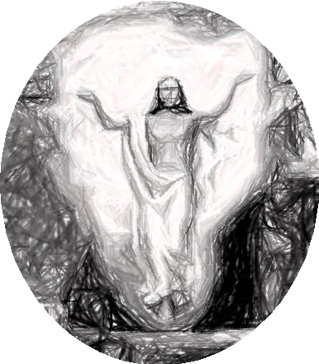
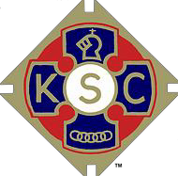
KNIGHTS OF ST. COLUMBA
SERVE GOD BY SERVING OTHERS

NATIONAL EASTER SCENE

PRIMARY SCHOOL AGE

PAINTING COMPETITION 2026

For KS 2 – School Year Groups 3,4,5 & 6, (8 to 11 years of age)
Winning entries go forward to the National Final for judging after the local rounds.

Required themes
- The entries should depict a scene of the entrant’s choice of a biblical incident recalled from Palm Sunday onwards through the Easter Season.
- Write Bible chapter and Verse that best relates to your scene on the picture or on the reverse of your sheet.

The competitors’ entries will be their own free hand and colouring productions; the use of pre-prepared tracings is not allowed. They may be sized A4 or A3, on paper of quality and colour of the entrant’s choice.
Schools and Parishes are asked, where possible, to make a preliminary selection of entries and choose no more than five to go forward to the competition as there may be individual entries.

The following detail should be shown legibly in full on the reverse of each entry:
Name and age of entrant, School Year Group. Name and full address of School
or Parish Group attended, and the contact details of a parent or guardian.

Entries should be handed in at Clergy House or to Father Martin after mass, by SUNDAY 29th MARCH 2026.

The awards after Provincial judging will be:
Copies of the winning entries in each group, signed Certificates and Cash Prizes of £10, £5, £3 (Charter Council) and £20, £15 & £10 (Provincial Co.) for 1st, 2nd & 3rd places respectively.

The awards to winners after National judging will be:
Certificates signed by the Supreme Knight and:
1st prize £30.00 and personal trophy, plus £200 to the school / church attended.
2nd prize £20.00
3rd prize £15.00

Results will be announced to schools participating and awards will be presented by arrangement with the winning school or parish and all entries returned.

