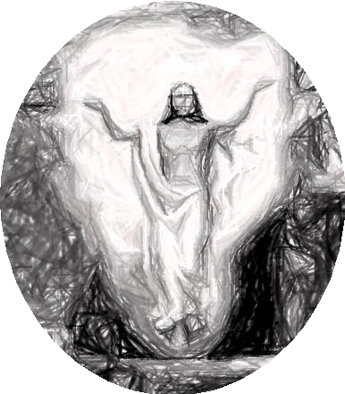
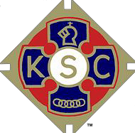
KNIGHTS OF ST. COLUMBA
SERVE GOD BY SERVING OTHERS

NATIONAL EASTER SCENE

HIGH SCHOOL AGE

PAINTING COMPETITION 2026

For KS Groups 3 & 4 – School Year Groups 7,8,9 & 10,11,12,13
Winning entries go forward to the National Final for judging after the provincial round.

Required themes
1) The entries should depict a scene of the entrant’s choice of an incident recalled during the period from the start of the Easter Triduum, (Feast of the Lord’s Supper), to the Feast of Pentecost. NB - In addition to the important and popular scenes of the Last Supper, those recalling Christ’s Passion on the first Good Friday and the Resurrection, there are the Journey to Emmaus, Appearances in the Upper Room and on the Shore of the Sea of Galilee, the Ascension, and Descent of the Holy Spirit on the Apostles. Each tell a significant story! Also, close-up scenes can show good detail!

2) Write a short Bible chapter and Verse that best relates to your drawing on the painting or on the back of your painting.
The competitors’ entries will be their own free hand and colouring productions; the use of pre-prepared tracings is not allowed. They may be sized A4 or A3, on paper of quality and colour of the entrant’s choice. Schools and Parishes are asked, where possible, to make a preliminary selection of entries and choose no more than five to go forward to the competition.

The following detail should be shown legibly in full on the reverse of each entry:

Name and age of entrant, School Year Group, Name & Address of School / Parish, and the contact details of a parent or guardian.

Entries should be handed in at Clergy House or to Father Martin after mass, by SUNDAY 29th MARCH 2026.

The awards after Provincial judging will be:
Copies of the winning entries in each group, signed Certificates and Cash Prizes of £10, £7, £5 (Charter Council) and £20, £15 & £10 (Provincial Co.) for 1st 2nd & 3rd places respectively.

Awards to winners after National judging are Certificates signed by the Supreme Knight and:
1st prize £75.00 and personal trophy, plus £200 & Certificate to the school / church attended.
2nd prize £50.00 3rd prize £25.00

Results will be announced to participating groups and awards will be presented by arrangement with the winning school or parish and all entries returned.

